Phase 3: Data Modeling & Relationships

**1. Standard & Custom Objects**

**Custom Object**: Registration__c

| **Field Label** | **Field Name (API)** | **Data Type** | **Field Type / Relationship** |
| --- | --- | --- | --- |
| **Registration Number** | Name | Auto Number | Standard Field |
| **Employee** | Employee__c | Lookup (Employee) | Relationship Field |
| **Course** | Course__c | Lookup (Course) | Relationship Field |
| **Status** | Status__c | Picklist | Custom Field |
| **Completion (%)** | Completion__c | Number (5,2) | Custom Field |
| **Feedback** | Feedback__c | Text Area (255) | Custom Field |
| **Created By** | CreatedById | Lookup (User) | Standard Field |
| **Last Modified By** | LastModifiedById | Lookup (User) | Standard Field |
| **Owner** | OwnerId | Lookup (User, Group) | Standard Field |

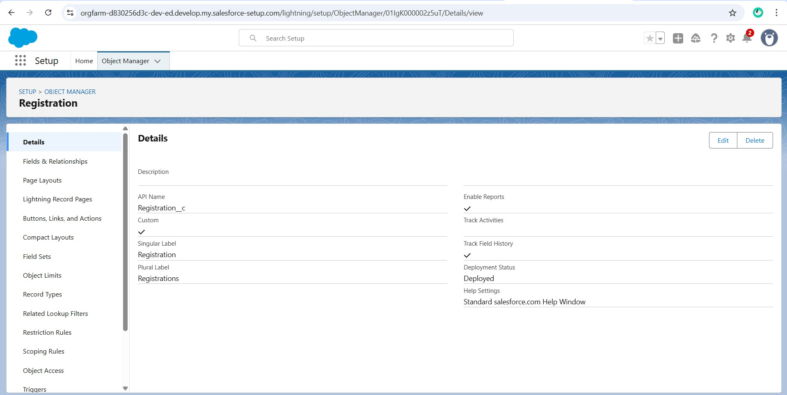

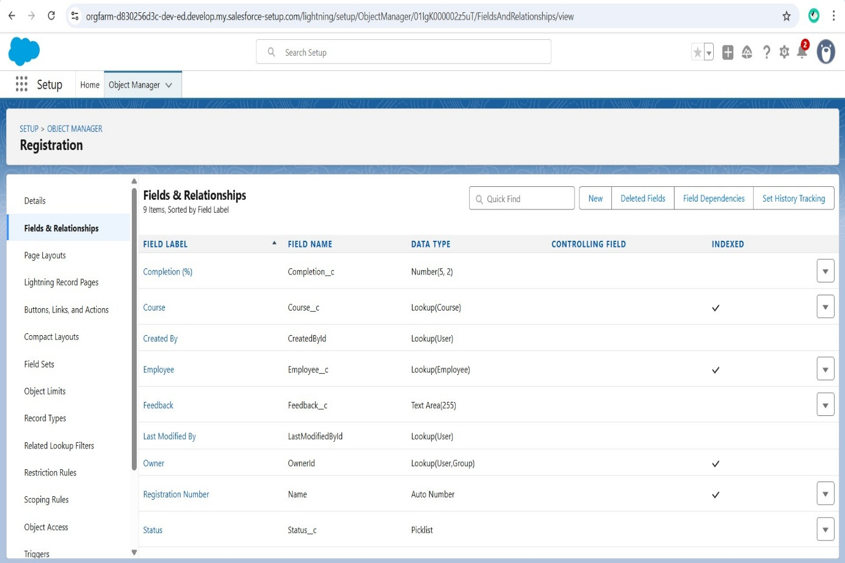

**2. Page Layouts**

**Employee Layout:** Basic info, Department, Related Registrations.

**Trainer Layout:** Trainer info, Expertise, Assigned Courses.

**Course Layout:** Course Name, Description, Duration, Trainer, Related Registrations.

**Registration Layout:** Employee, Course, Status, Completion %.

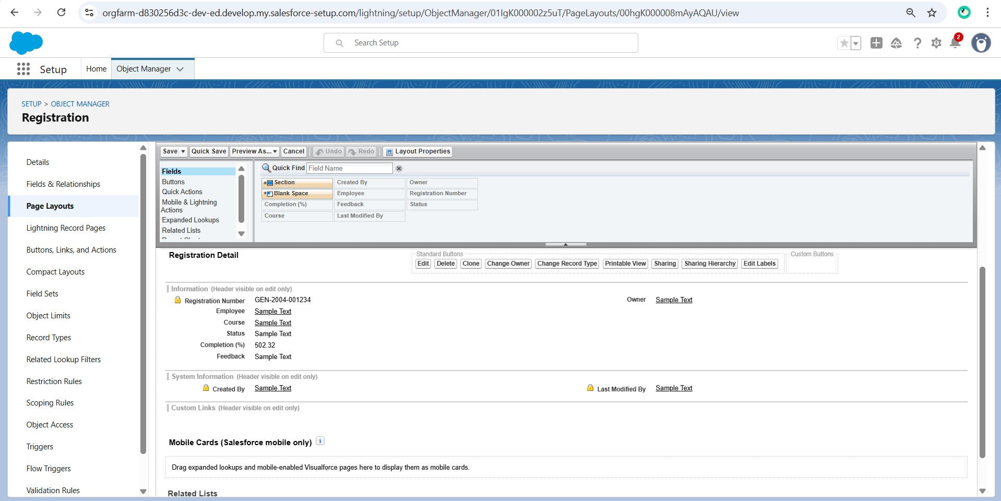

**3. Schema Builder**

The Schema Builder provides a visual representation of all objects, fields, and relationships in your Salesforce org.  
It helps understand how Employee, Trainer, Course, and Registration are connected.

* Verified field relationships (Lookup and Master-Detail).

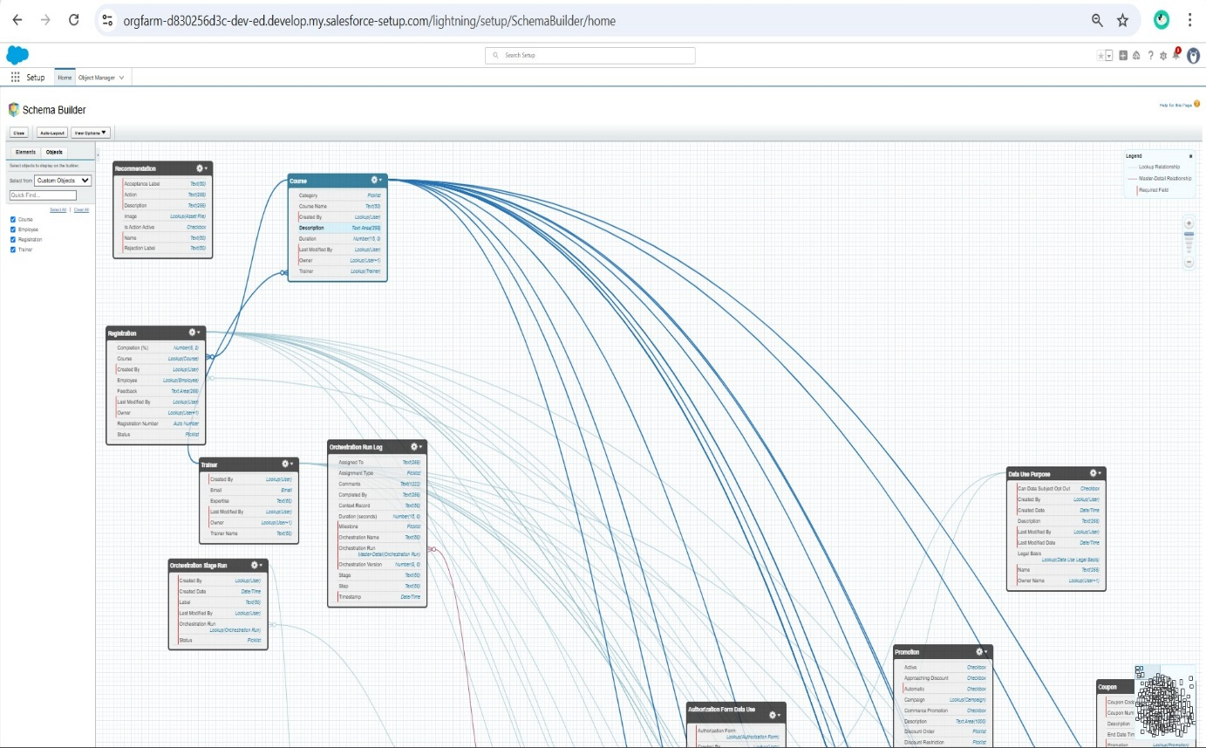

**4. Lookup vs Master-Detail vs Hierarchical Relationships**

**Lookup Relationship:**

Employee → Department

Course → Trainer

Registration → Employee

Registration → User

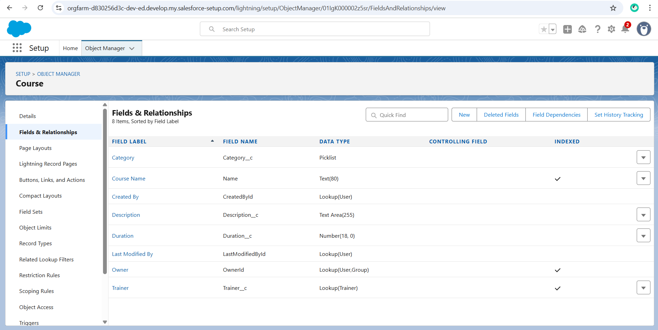

**5. Field Level Security**

**HR Admin:** Full access to Employee, Course, and Registration objects except Salary.  
**Trainer:** Can update course progress and view employee details.  
**Employee:** Can view available courses and submit course feedback.

